
Name:

MATHEMATICS SPECIALIST 3CD

SEMESTER 1 2010

TEST 4

 | Questions | Working Time | Marks | Score
Calculator Free | 1 – 3 | 18 minutes | 16
Calculator Assumed | 4 - 8 | 42 minutes | 38
Total |  |  | 54

1. [1, 2, 2 marks]

Differentiate the following:
(a) 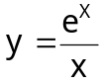.

(b) y = ln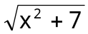

(c) y = log_{a} (3x + 2)

2. [5 marks]

Given 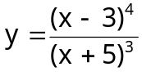 complete the expression below:

ln y = a ln (**) – b ln (**) and hence by implicit differentiation evaluate 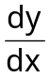.

Simplify your answer in terms of x

3. [6 marks]

A cinema photographer is wishing to keep track of an elevator (lift) which is moving at 3 m/s vertically upwards on the outside of a building. The camera positioned on the ground 30m from the base of the building. Calculate the rate of change of the angle of elevation of the line of sight of the camera when the lift is 40m from the ground.

Name:

MATHEMATICS SPECIALIST 3CD

SEMESTER 1 2010

TEST 4

 | Questions | Working Time | Marks | Score
Calculator Free | 1 – 3 | 18 minutes | 16
Calculator Assumed | 4 - 8 | 42 minutes | 38
Total |  |  | 54

4. [6 marks]

The acceleration of a body moving along a straight line is given by:

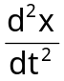 = -25π²x

where x cm is the displacement of the body from a fixed point on the line and t is in seconds.

Find an expression for the position of the body at any time and in the form

x(t) = A sin (kt + c)

given when x = 6 v = 0 and also when t = 0, x = 3 and v < 0.

5. [3, 2, 1, 2 marks]

Assuming that that the rate of cooling of a body is proportional to the temperature difference between the body and the medium it is contained in is given by the differential equation
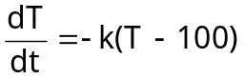

where T° K is the temperature of the body and t is the time in minutes.

(a) If the original temperature of the body is T = 150° K, the surrounding medium is 100° K, use the above constraints to show that the equation for the temperature of the body is

T(t) = 100 + 50e^{-kt} where t is in minutes and T is in °K

(b) Given that the body cools to 135° K in 10 minutes evaluate k to 4 d.p.

(c) What is the temperature after 20 minutes?

(d) How long, to the nearest minute, will it take for the body to cool to 120° K?
6. [1, 1, 2, 2, 2 marks]

The magnitude of an earthquake, as measured by a seismograph, is determined by the amplitude of waves recorded on the machine where A₀ is a fixed amplitude that readings are compared to.
The magnitude M is determined by the equation M = log₁₀ 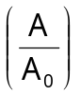
where M = Magnitude of the earthquake
A = Amplitude recorded on the machine during the earthquake
A₀ = A fixed value for the seismograph

Calculate the following:

(a) A in terms of A₀ for M = 1·5

(b) M given A = 70A₀

It is estimated the energy released by an earthquake is given by the equation

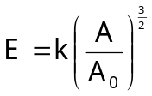 where A and A₀ are the amplitudes from above.

Given an earthquake of magnitude M = 0 releases 4·2 mega Joules (MJ) of energy, calculate the following:

(c) the value of k,

(d) the energy released by an earthquake of magnitude M = 2·0

(e) the magnitude of an earthquake which releases 23·5 MJ of energy

7. [6, 2 marks]

Mountain rescue team can travel along a straight bush track at an average of 8 km/h and 5 km per hour off the track. They wish to reach an injured walker as soon as possible. The injured walker is located 6 km along the track and 5km into the bush. (See the diagram.)

(a) Calculate how far along the track the team should leave it and make a bee-line through the bush to the walker in order to minimise the time taken. Give your answer to 2 d.p.

(b) Also give the minimum time taken, to the nearest minute.

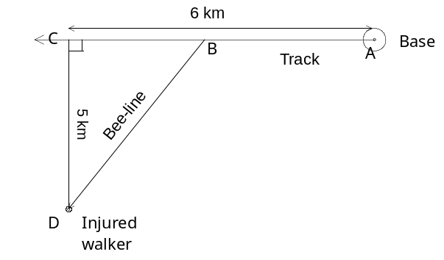
8. [4, 2, 2, marks]

A particle moves in a straight line such that its acceleration is given by
a(t) = 2t – 10 m.s⁻²

Given that when t = 0 the particle was at x = 0 and its velocity was 16 ms⁻¹ answer the following:

(a) Calculate when the particle was stationary for t>0.

(b) Calculate the equation for the displacement of the particle.

(c) Calculate the time(s) when the particle is at the origin (zero displacement position).

